 |  | ACC Learning  & Teaching Support Unit
Maps on the Web
This document aims to summarize a variety of web-based map resources. Some resources simply provide basic maps of an area, while others allow the user to add pre-selected data. They are suitable for a variety of purposes such as illustration, basic data analysis, finding places and locations, travel directions and so on. It is split into the following sections:

- Local Authority maps and data
- National / regional – UK
- National / regional – non UK
- Global
- Appendix A – other places to look
- Appendix B – map copyright

Some of the sites listed give a useful demonstration of how GIS works, without having to learn how to set up and use a real GIS. This document does not advise on sources of material suitable for desktop GIS (such as ArcView).

- Local Authority maps and data

Many local authorities now have some type of online mapping system that enables anyone with an interest in that area to view information spatially. The main example shown here is that of Nottingham City Council with NOMAD. This type of system is becoming more popular and increasingly other local authorities have similar systems that integrate a variety of functions such as decision making and planning, and illustrate them in terms of issues like health, transport, housing etc.

NOMAD (Nottingham Online Maps And Data)
http://webgis.nottinghamcity.gov.uk/website/nomad/index.asp?app=WWW_Esri#

This online service allows users to view geospatial information about the City of Nottingham. While its geographic scope is very small, it allows users to map a large amount of local data. The following example shows a clickable map (ie – icons on the map can be clicked for information about a specific feature) of the locations of doctor’s surgeries and hospitals:

Unfortunately, NOMAD is particularly protective of its copyright, with a feature that stops users from right-clicking on the map area to download a map, such as the one produced above. It is possible to use the “print map” button to obtain a paper copy.

It is also worth noting that the NOMAD site is not a source for local data and maps for use in GIS software.

Other Local Authority GIS:
The following is a brief list of local authority GIS that provide further examples of the ways GIS can be used at a local level. They also provide maps and data that may be suitable for project work.

Royal Borough of Kingston upon Thames
http://maps.kingston.gov.uk/

East Hampshire District Council
http://82.109.140.215/map/

Southwark Council
http://www.southwark.gov.uk/YourServices/maps/webmapsinternetmapping.html

There are many others not listed here that require technologies such as Java and ActiveX to work. As these technologies may not be available to you, these sites have not been listed.

- National / regional – UK

Commercial free-to-use
The following UK-based mapping services all work in a similar way – they provide free, simple maps of the UK, in conjunction with advertising (but little or no data). They include:

http://www.streetmap.co.uk/
http://www.multimap.com/
http://www.ordnancesurvey.co.uk/oswebsite/getamap/
http://www.uk.map24.com/
http://www.mapquest.co.uk/
http://maps.yahoo.net/

Of these the best is arguably multimap.com. It is simple to use, reliable and has a comparatively large map display. It also has an option called “Aerial Photo” that allows you to view maps as satellite images with conventional map details super-imposed.

Also of note is http://maps.google.co.uk/. This combines satellite imagery with conventional maps. However, it is currently only available as a beta (test) version, and cannot be used to save maps.

Ordnance Survey (Digimap)
http://edina.ac.uk/digimap/

Ordnance Survey is one of the main suppliers of maps and data in the UK. Under an agreement with UK universities, much of its maps and geographic data are supplied at a reduced rate with a scheme is known as Digimap, making them free for staff and students to use for educational purposes.

Digimap requires individuals to complete a fairly lengthy registration process before access is given to Digimap materials, so in this sense Digimap is not as quick or easy to use as the other sites listed here. However, it does have a huge range of maps and data available, suitable for a variety of purposes, including data for use in GIS. As such, it is probably the best place for staff and students to get maps of the UK, and requires separate documentation to describe its many parts.

- National / regional – non UK

Nationalatlas.gov
http://www.nationalatlas.gov

This site (at the time of writing) contains seven main sections, the most relevant of which are discussed in further detail below. While it concentrates exclusively on the United States, the quality and quantity are very good, making it recommended for anyone with a need for maps or data relating to the USA.

Map Maker
http://www-atlas.usgs.gov/natlas/Natlasstart.asp

Details:
It contains many layers of data (too many to list here) grouped into themes such as agriculture, transport and climate. It is easy to draw and re-draw maps combining different data themes. The main limitation is that it is often not possible to show different layers of data simultaneously – one layer will over-write another, if both layers contain shaded areas. Also, it does not allow user data to be plotted as a true GIS would.

The map on the next page shows water resources of the continental USA, and was drawn in a few minutes:

Map Layers
http://www.nationalatlas.gov/maplayers.html

This section allows visitors to download data for use in their own desktop GIS. The data itself is the same as that already available in MapMaker (above), and is split into the same themes as in MapMaker. Data files are available as shapefiles (which work in ArcView), but are compressed for download as GZIP files (for which a utility such as Stuffit Expander http://www.stuffit.com/win/index.html is needed). Once downloaded and unzipped, the data should work seamlessly with desktop GIS.

Baltic Environmental Atlas
http://vitalgraphics.grida.no/balticmap/

This site focuses on the Baltic region, specifically the land area that drains into the Baltic. There are basic layers showing features such as lakes or capital cities that are switchable, and data themes such as population and topography. It is a simple, easy to use facility, but only likely to be of interest to someone with an interest in this region of the world.

Interactive Map of Iraq
http://blue.geog.ttu.edu/website/iraq/viewer.htm

This facility actually covers much of the Middle East, but provides additional data for Iraq, making it useful for anyone with an interest in this area of the world.

As with other map and data viewers here, there are various map layers that can be switched on or off. What distinguishes this site are the particularly comprehensive navigation tools (approaching the functionality of a desktop GIS interface) and the quality of some of the layers, such as topography, which are quite detailed.

Census 2000 (USA)
URL: http://censusmap.binghamton.edu/cit_county/viewer.htm

This facility gives you access to information from the 2000 US census. The map is principally there as a navigational tool, rather than something that can be altered and used in its own right (although the simple line map can have a Highways layer added). Simply select the Information tool, click on a state, and a table will appear (see illustration below) giving detailed census data about that state.

One word of warning though – sometimes it is slow to load.

- Global

Commercial free-to-use
It is worth noting that some of the commercial sites covering the UK also give some global coverage. Try:

http://www.multimap.com/
http://www.uk.map24.com/
http://www.mapquest.co.uk/
http://maps.yahoo.net/

National Geographic Map Machine
http://plasma.nationalgeographic.com/mapmachine/

This facility has been thoroughly revamped since 2002, in partnership with ESRI. Not only is there a greater range of data and map categories to see, but there are more simple easy-to-use tools (whose availability depends on the type of map) such as:
- layers of data that can be switched on or off
- a simple annotation system
- measuring tool

As before, it focuses on displaying data from within MapMachine itself, and is not a tool for creating maps or plotting your own data. However, it is worth noting that for some regions, road and street maps can be created in a similar fashion to MultiMap.com, making this a versatile resource. Data does focus on the USA, but global information is available.

If there is one criticism, it is that if you want to save a map, it has to be saved as a cookie. It is not possible to simply right-click and save the map as an image, which would be useful.

There are too many options to note here, but the following categories are included:
- World Maps
- Countries and Continents
- Outdoor Recreation
- Conservation and Ecology
- Trip Planning
- Space
- Educators and Students
- Historical Maps

Over-page is an example created in Map Machine, showing earthquake sites in central America:

Geography Network
http://www.geographynetwork.com

Geography Network is run by ESRI “to promote the sharing and discovery of geographic information and services”. It provides users with a wide variety of map resources, including maps suitable for saving a printing from a web-browser, and browser based GIS.

Some elements of the site act as a commercial “shop window” for ESRI products, such as ArcView (available in all good computer rooms). As such, it is not always clear what is available for free, and what has to be paid for, until (after clicking a lot of links) you are suddenly asked for payment.

However, with perseverance there is a lot of data available covering many regions of the world, including data suitable for use with GIS.

About.com Geography
http://geography.about.com/

About.com is a predominantly American site. Owned by the New York Times, it is written by a group of five hundred “guides” (as opposed to the more anarchic authorship of Wikipedia).

The Geography section is edited by a guide called Matt Rosenberg. He has included a wide variety of resources including:
- Free maps
- Data
- Frequently asked questions about Geography
- Quizzes
- Articles on a verity of geography related subjects
- Links to external sites for things such as photographs, jobs and other things that relate to the subject of geography

In all this site is comprehensive, written with enthusiasm, and has a wide variety of geography resources that are easy to access.

Windows Live Local (aka MSN Virtual Earth)
http://local.live.com/

This site is currently at the beta testing stage. It displays good quality road maps based on those used in MS MapPoint, giving coverage of the US and the UK to a detailed level. Coverage of the rest of the world is limited in detail, but this should improve with the final release.

One note of caution though – there seems to be no way of saving maps, which may limit the usefulness of this site.

3D map viewers
These are desktop applications that have to be downloaded to your PC, and then used with a live internet connection. Because of the need to download and install software, these applications are not suitable for use in student resource rooms, but may be of use to those working on their own PC, with a broadband connection.

The maps used are updated via the internet as they become available. The “maps” themselves are actually imagery taken from satellites and as such look like photographs, rather than conventional line maps, and give good coverage of the entire globe.

Google Earth
http://earth.google.com/

Google Earth is easy to use and navigate. While it is free, the commercial side of things is never far away – there are layers of information relating to businesses (as with many web-based map systems), and to get all the functions available, you have to pay for Google Earth Plus. However, standard Google Earth is still highly recommended.

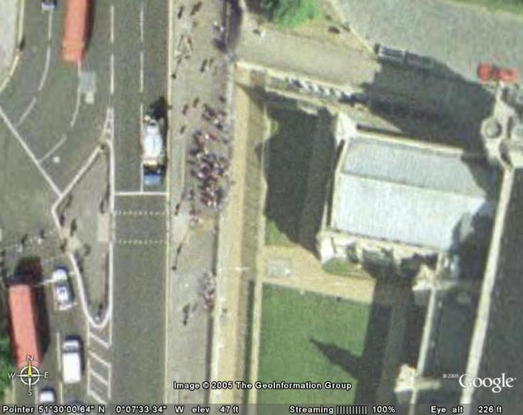

Compared to Google Maps (or Multimap.com), the quality and resolution of images is higher, as shown above (this image shows people queing to enter the House of Commons). However, the resolution does vary according to the type of satellite imagery used for a particular area (try comparing East Midlands airport with Clifton campus) so the quality varies from good to very good.

Map imagery is easy to save, and addition information can be added in the form of pushpins that show text, or images for illustration, directly on your copy of Google Earth. In addition, layers can be added – in the example below, roads have been added to an image of Nottingham:

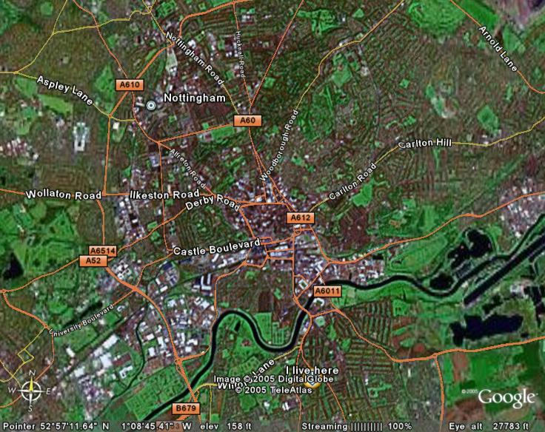

It is also tremendous fun. Think of it as a cartographic flight simulator, and revel in the sometimes spooky detail it shows (like the alterations made to a house you used to live in, or the craters covering much of Nevada made by atom bomb tests). Who knows, it may inspire you to learn more about the world...

NASA World Wind
http://worldwind.arc.nasa.gov/
NASA World Wind 3D application

This is similar to Google Earth in conception, but suffers from appalling usability problems. Don’t bother with it.

- Appendix A - Other places to look:

ESRI IMS user registry
http://gis.esri.com/ims/index.cfm
A search facility that allows users to look for online mapping applications. Unfortunately, they mainly seem to be for viewing existing and very specific data, and those in English seem to be US biased.

Google Local
http://maps.google.co.uk/
http://maps.google.com/
This facility is mainly focused on finding places – for example business addresses. As such it is more like a spatial phone directory than a data viewer. In terms of maps, they can’t be saved or re-used – only viewed in the browser - making this a poor source of maps at the moment.

Satellite imagery
Satellite imagery is quite a specialized product. It is suggested that you try the “Aerial photo” option in Multimap.com, or use Google Earth if this is possible. However, there are further sources if more detail, or more specialist imagery is needed. Here are some suggestions to try:

NASA Bluemarble
http://earthobservatory.nasa.gov/Newsroom/BlueMarble/

Flatplanet maps
http://flatplanet.sourceforge.net/maps/

Orbimage
http://orbimage.com/

WorldKit
http://www.brainoff.com/worldkit/index.php

Worldkit is true web-based GIS. It requires good technical skills to use (specifically HTML and XML) so may only be of use to those with backgrounds in GIS or web development.

However it has some very interesting examples of web-gis projects set up using WorldKit software: http://www.brainoff.com/worldkit/examples.php

- Appendix B - Map Copyright

Maps are covered by the same copyright laws as other pieces of published work. The ease of availability that mapping websites promote does not mean that the maps they provide can be re-produced free from restriction. Therefore in terms of copyright, treat maps (in either printed or electronic form) as you would any other materials such as images or text.

Treat data with caution - the Google Earth Bomber…
It is not unheard of for map producers to play tricks to protect their copyright. In the past producers of street maps have been known to add imaginary streets in order to prove that any one else’s maps that included these streets had copied theirs. Could the Google Lancaster bomber shown here be the modern equivalent?

