 |  | ACC Learning  & Teaching Support Unit
SNAP tutorial 4 – Analysing the results
This document is the first of four that aim to instruct the user through the various stages of using SNAP 7. These documents are:

- SNAP Tutorial 1 – Questionnaire design
- SNAP Tutorial 2 – Data Entry
- SNAP Tutorial 3 – Internet Module
- SNAP Tutorial 4 – Analysing the results

This document covers the following:

- Viewing Absolute Figures and Percentages
- Filtering data
- Cross-tabulation
- Analysing Open questions
- Exporting data for use in spreadsheet software

These instructions assume you have created a questionnaire in a SNAP. As with the instructions in previous handouts, this tutorial uses the generic Geography module feedback questionnaire as an example.

- Viewing Absolute Figures and Percentages
If necessary, open your survey from the H drive.  Click the Case Data toolbar button to view the questionnaire in Data View: | 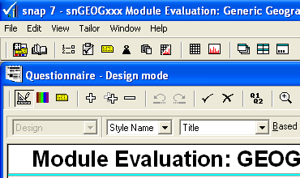

From the second menu that appears below, select the Counts option:  You now have the option of viewing data as absolute figures… | 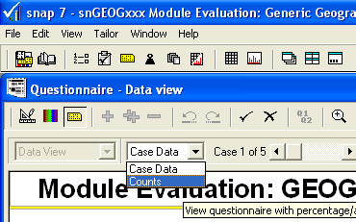

… or percentages:

Select Percentage to display questions recording nominal data as frequency proportions (the count as % of total responses); Select Absolute to display the frequency count (the actual number of responses in each category).

Note: in the example here, the free text box for “Other programme” does not display text entered. Instead, a tally of the total number of responses entered here (just one, or 20%, in this example) is shown. Dealing with free text responses is covered below.

- Filtering data
As with Percentages and Absolute figures, make sure that you are in Data View. This gives us the Filter toolbar button:

- Firstly, make sure that you have selected either Absolute or Percentage, as appropriate.  - Click the Filter toolbar button to bring up the Filter dialogue box: | 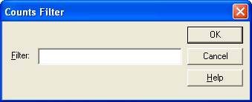
- Enter the question number, followed by the equals symbol, and the number of the response you want to select with:  In our example survey, this brings up all the results (three out of five) where respondents indicated that they were doing Human Geography: | 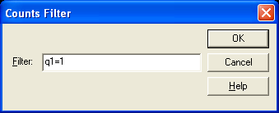

To use the filter effectively, you need to know the number of a particular question. This is not necessarily shown on screen in Data View. To ensure that you are using the correct number click the Variables toolbar button:

This brings up a list of information about each question, including the exact number that Snap has given to each part of each question.

This is particularly useful in situations where multiple choice questions use a free text box for “Other” replies (in the example above, the “Other” option is numbered as Q1a), or with Grid questions where each line in the grid has a different letter to identify it (for example, Q2a, Q2b etc) – these letters must be included when using a filter, to correctly identify the particular part of the question you want to work with.

- Cross-tabulation
Cross-tabulation allows you to compare the results of one or two questions by creating a table that gives a visual reference.  - Click the Results Table toolbar button: | 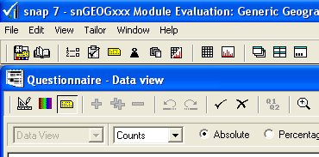

The Results Definition dialogue box opens, enabling you to cross-tabulate results from different questions.

In the following example we will look at how those respondents doing Human Geography rated their support from tutors. To do this, we will cross-tabulate question 1 with question 2d. Enter the name of the first question to be analysed in the Analysis box:

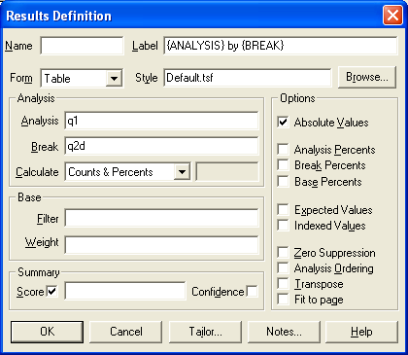

- Enter the name of the second question in the Break box. Note that the Absolute Values checkbox is ticked. This means the results will be presented as absolute figures rather than in percentages.

- Click OK. The result should appear in a window like this:

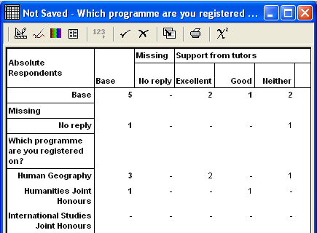

Note: as with using filters, questions are typed using the letter Q followed by the question number, and letter if appropriate.

If necessary, widen the window to see the full results:

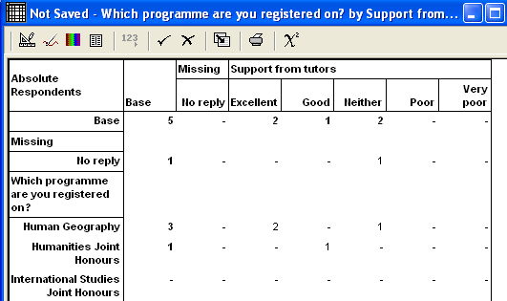

In this limited example with just five respondents, we can see that for the three Human Geography students two rated their tutor support as “Excellent”, and one as “Neither”.

A limitation in this particular example is that one of the five respondents is classed as “Other”. This means that a new tabulation would need to be done using question Q1a in place of Q1.

The Results Definition dialogue box can be used in different ways. For example, instead of Absolute Values, percentages can be specified, as shown here:

Filtering is also possible, using the same rules discussed in the previous section of this document.

- Analysing Open Questions
You may use information in open questions for quotations to illustrate opinions, in which case you can get a listing from SNAP, showing the case number for each comment.

If you want to use responses in further analysis, you will need to code them to create additional variables.

Printing a list of open text responses
- Click on the Case Data toolbar button, and select Prompted Mode:

You can now see the responses to open text questions.

- Click on the printer icon to display the data report window. The Data Report dialogue box should now appear:

- Type in a suitable title:  - A filter can be used to display specific information:  - In Content enter the name of the question you want to print: | 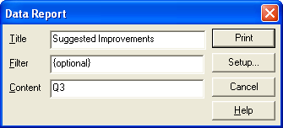

Note that it is possible to print more than one question in a report. Simply type a comma after the first question number, then add a second question number. Be warned however that you may need to use the Setup button to squeeze the data onto the page.

Extracting text
It is possible to extract text so that it can be pasted into reports or other documents. This is most easily done in Questionnaire mode:

Text can simply be highlighted and copied from an open text box.

- Exporting data for use in spreadsheet software
A common requirement for Snap users is to be able to export data for use in other applications, most commonly for use in spreadsheet software. This example demonstrates how to export Snap data to MS Excel.

In Snap:

Click the Case Data button:

Go to the File menu, and click Export. The following dialogue box should appear:

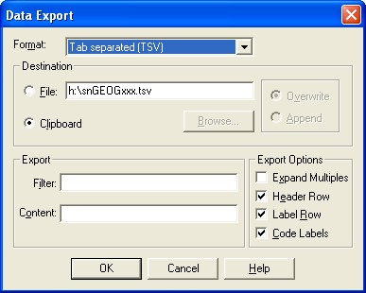

From the Format menu, select Tab separated (TSV).

Click the Clipboard option below (this enables data to easily be pasted into another application).

In Export options, if you want to, select options that you require:

Expand Multiples. To be brutally honest, when testing this feature it didn’t seem to do anything.

Header Row. This will add a row above the exported data, containing question numbers (eg Q1, Q1a, Q2a etc).

Label Row. This will add a row containing question labels (eg “Which programme are you registered on?”, “0ther programme”, “Module handbook” etc)

Code Labels. This changes the way data is formatted from this (No Code Labels)…

Numbers make NOT using code labels more suitable for creating graphs.
… to this (Code Labels selected):

This doesn’t require the use of codes to interpret.

As ever, it is also possible to Filter data.

Once you have selected the options you want, click OK.

Open Excel, and in a blank spreadsheet, simply go to the Edit menu, and select paste. The data should appear as shown in the two examples above. You may want to widen columns.

