 |  | ACC Learning  & Teaching Support Unit
SNAP Tutorial 2 – Data Entry
This document is the second of four that aim to instruct the user through the various stages of using SNAP 7. These documents are:

- SNAP Tutorial 1 – Questionnaire design
- SNAP Tutorial 2 – Data Entry
- SNAP Tutorial 3 – Internet Module
- SNAP Tutorial 4 – Analysing the results

This document looks exclusively at entering data into a snap survey, and covers:

- Re-opening your survey
- Entering Case Data
- Appendix: a note about data files

These instructions assume you have created a questionnaire in a SNAP. As with the instructions in the Tutorial 1 handout, this tutorial uses the generic Geography module feedback questionnaire as an example.

SNAP terminology – a reminder
SURVEY – the data file recording all the information for one exercise (all SNAP files are prefixed ‘sn’)

CASE – the results taken from the questionnaire filled in by one respondent

- Re-opening your survey
If necessary, open the SNAP survey containing the questionnaire:

- Select SNAP7 from the START menu > common applications > statistical programs. Snap should now open to the Survey Overview window:

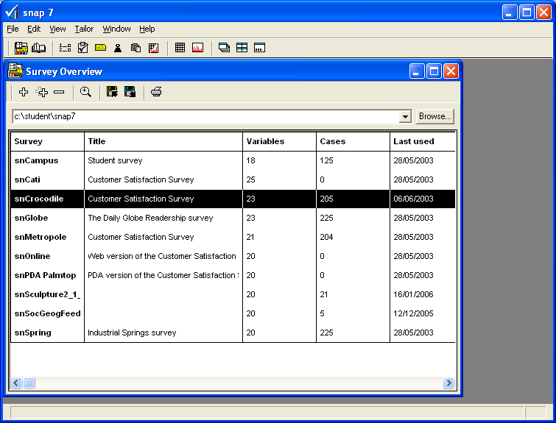

- Assuming that you saved your work to the H drive as suggested in the last document, click the Browse button to select the H drive, and open the survey from there:

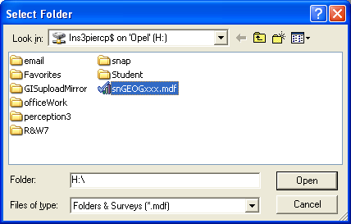
- To open the survey, double click on it. The Survey Details dialogue box should now open, confirming the title and details of the survey.

- If you are adding cases to a partially completed survey, check that the right number are in place before you start. Assuming the details are correct, click OK.

The survey should now open in Design Mode:

- Entering case data

- To enter case data, click on the Case Data toolbar button. Be careful to click the button indicated here, as there is another identical looking button below that you do not want to click!  The following screen should now appear.  Note that the survey is in Prompted mode: | 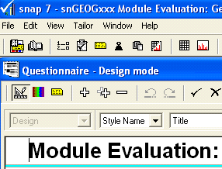

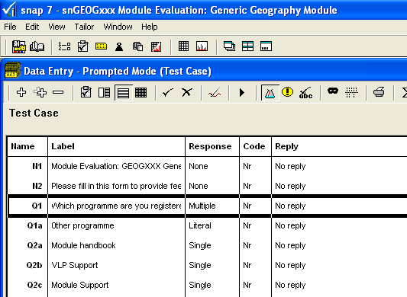

If you have yet to enter any data, you will see “Test Case” written underneath the toolbar. If you have already entered data, a scroll bar will appear instead, allowing you to move from one case to the next:

- Switch to Questionnaire mode, by clicking on the Questionnaire mode icon. This is the most convenient mode in which to enter data.
- To add a new case, click the New Case icon on the toolbar.

If this is the first case in your survey, the Case data scroll bar should now appear for the first time:

You are now ready to enter data!

Note that while the questionnaire looks the same as it did in Design Mode, it works in a different way.

- When you click into a tick box, a tick appears.

- When you click into a text box, you can type text.

When typing in responses to open questions, if you have more than one entry, continue on the same line - don’t press ENTER until you want to move to the next question.

- After you have completed the last question, press ENTER, and the following toolbar should appear: | 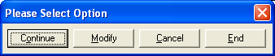

- Click Continue to add another case, or End to finish adding case data.  You may get a warning if some questions are blank:  If this happens, click Yes to continue. | 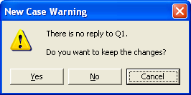

NB if you have used ‘other’ after a multiple choice this will be treated as a separate question, so will increase the number of questions not completed.

Alternatively, you can use the New Case button to add another case. You can (in theory…) also use the Delete Case button to delete data. However, while this may delete the data, it won’t delete the case.

The Case scroll bar should expand automatically to accommodate each new case, allowing you to move from one to the next:

If conducting a paper questionnaire, write the case number shown by Snap on the paper version.

The new case will be saved into the SNAP data file – check that the ‘case number’ of the last questionnaire entered matches the number on the paper copy.

You can continue with the next question by clicking the ‘+’ sign; remember to write the new case number on the paper copy.

Given that this documentation is aimed at staff members seeking module feedback from students, it is assumed that the bulk of data captured will be done so via the internet. The next document in this series, Snap Tutorial 3 – Internet Module deals with this.

- Appendix: a note about data files
When you create case data in a Snap survey, Snap creates a new file to store this data in.

This is important to know about when moving snap files to a new disk drive, network drive or folder, because both files must be kept together in order to work.

A Snap survey file has the file extension .mdf.

Case data is stored in a corresponding file with the same name, but with the .rdf extension.

In the worked example, the files used are accordingly:
survey file: snGEOGxxx.mdf
data file: snGEOGxxx.rdf
If moving or copying (or deleting) your survey, look for both files with these extensions and always keep them together.

