 |  | ACC Learning  & Teaching Support Unit
SNAP Tutorial 1 – Questionnaire design
This document is the first of four that aim to instruct the user through the various stages of using SNAP 7. These documents are:

- SNAP Tutorial 1 – Questionnaire design
- SNAP Tutorial 2 – Data Entry
- SNAP Tutorial 3 – Internet Module
- SNAP Tutorial 4 – Analysing the results

This document covers the following:

- How Snap works
- Designing the questionnaire
- Question types
- Questionnaire layout
- Printing

SNAP is dedicated survey software that will allow you to set up a questionnaire with a variety of question styles, print a paper copy of your questionnaire, enter data directly into the questionnaire format, and analyse the results. It has many different modes of use and functions, including internet delivery using either the web or email.

These notes are designed to provide sufficient guidance on the basic functions to get you going – use the inbuilt ‘help’ to investigate more sophisticated uses!

This tutorial uses a generic Geography module feedback questionnaire as an example – you will not be able to open this, but there are other surveys on the system you could look at.
- How Snap works
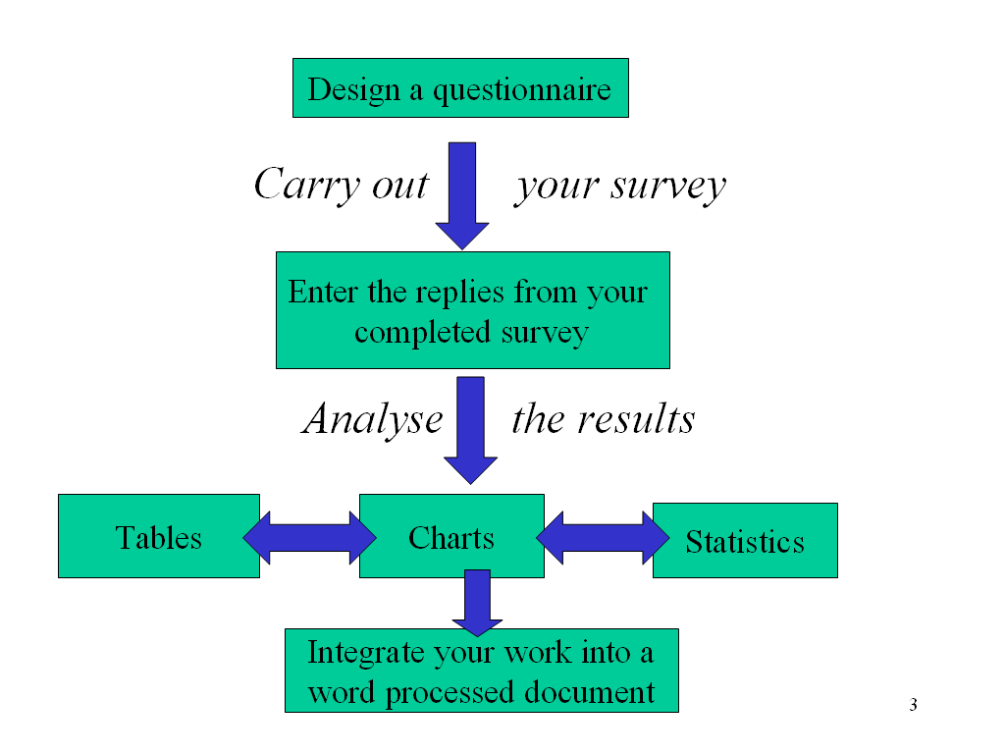

SNAP terminology
SURVEY – the data file recording all the information for one exercise (all SNAP files are prefixed ‘sn’)

CASE – the results taken from the questionnaire filled in by one respondent

- Designing your questionnaire

Select SNAP7 from the START menu > common applications > statistical programs

When SNAP starts, it defaults to the C: drive

It is advisable to change this to save work to your H: drive (click the Browse button and select H:).

Check that it is now showing the drive you want

Creating a new survey
Click on the plus sign to create a new survey:

The dialogue box shown below should now appear:

Type in a name for your survey - SNAP will add the prefix “sn”.

Then add a title to describe your survey, and click OK.

Snap should now be ready for you to start creating your survey.

Type in the heading you want on the questionnaire, and press Enter.

The subheading box should now appear underneath:

The subheading section provides an opportunity to enter instructions to respondents:

Once you have entered a suitable subheading, press enter and Snap will be ready for the first question:

- Question Types

‘Open’ questions
Open questions can be used in two ways in SNAP:

Free text response
Respondents write their own free-text comments that can either be coded later or used as quotations. This can also be used to record numeric data.

Multiple Choice “Other” response
Snap allows free-text boxes to be attached to conventional multiple choice / response questions to cater for options not given.

‘Closed’ questions

Multiple choice

Respondents select one from a list of pre-set responses.

Multiple response

Respondents select any number of responses from a pre-set list.

Grid
Respondents make repeated choices from a set of responses, usually used to rank quality.

Example 1 - Setting up a Multiple Choice question
- The default question style is multiple choice. | 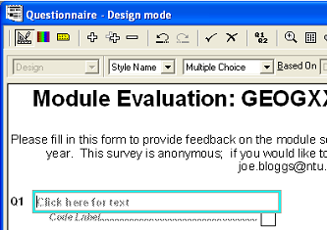
- Type your question into the box:  - Press the TAB key to move to the first code box. | 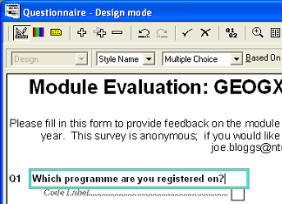
- Pre-code the most likely choices (best derived from a pilot study using open questions): | 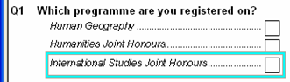
- After the last pre-coded response hold down the [Ctrl] key and press ENTER. The style name changes to “other”.

Type a suitable title:

To enlarge the space for the response, hold down the [Ctrl] key and press the [+] key.  - Press ENTER to move onto the next question. | 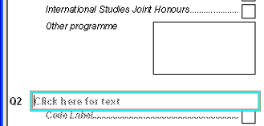

Note - Specifying single and multiple response questions

If you do not specifically tell snap to do so, it will format single response questions in the same way as a multiple response question. This could result in a respondent giving two or more responses to a question only designed to handle one response, or a result in a multiple response question that is only able to take a single response. Either scenario could result in compromising the quality of your data. It is therefore important to specify which type of response you want for a particular question. To do this:
1. Click questionnaire design button:

2. Go to the question you want to check, and highlight all the options listed:

3. From the second menu in the survey window, select Response

4. Select single or multiple as appropriate – apply to questions individually

Once the survey is ready to input data (see following document, SNAP Tutorial 2 – Data Entry) check that single response questions do not accept multiple responses, and multiple response questions are capable of accepting more than a single response.

Example 2 – Setting up a grid question
- Select Grid First for the first part of a Grid question.  - Start the grid question with an instruction, then press the |  | 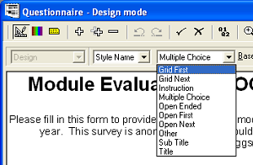
down arrow key to move on to the rank labels.

- Type the first rank label, press the TAB key, and the next grid box appears, ready to be labelled.
- Complete this process, until you have labelled all the columns:

You may find that the labels are compressed - you can adjust that later.
- After typing the last column label, click into the first row label area. Type in the first heading, and press TAB to move to the next row: | 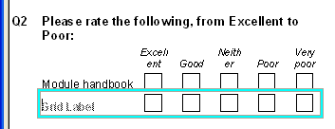
- Once the list is complete, press ENTER to move to the next question:

Example 3 – using an open ended question to capture numeric data
This example involves respondents entering numbers into three text boxes.

- Select the Open First question type for this:

- Press the TAB key to add further open text boxes.

Note that SNAP automatically formats additional text boxes as Open Next questions.

Example 4 – using an open ended question to capture free text
To get free-text responses, use the Open Ended question type:

To make the box bigger hold down the [Ctrl] key and press the [+] key several times:

You can make the box smaller with

[Ctrl] [-]

- Questionnaire layout
To change question order
- To change the order of the questions, select the question you want to move – it should become highlighted:

(if you have problems with highlighting the correct question, try clicking on the blank space to the right of the question you want to move)

- To move the selected question hold down the [Ctrl] key and press up or down arrow until it is in the new position

- Click the renumber toolbar button to put the question numbers back in sequence:

To change questionnaire layout
SNAP has many features to enhance the layout of your questionnaire. Your choice will depend on the length and complexity of your questions, and whether the questionnaire is to be used for an interview or completed by the respondent.

The simplest layout is to use ONE column spread across the FULL-PAGE.

- Click the Edit Styles toolbar button:

The toolbar underneath should change from this…

…to this:

- In the first menu, make sure that All Styles is selected.

- In the second menu, make sure that Columns is selected.

- Click the Full Page button. The questionnaire should now broaden out to fill the full width of the screen:

Note:- that the column headings in the Grid question have automatically widened.

- Click on the “tick” toolbar button to save your work:

- Printing

Self-Completed Questionnaire
Try to keep to a maximum of 2 sides A4 so you can ‘back’ it when you run off copies – more sheets puts respondents off!

Interview Questionnaire
Save space by reducing the font size for the questions – use space for observations/comments.
Make up ‘prompt cards’ in large print to show respondents for long lists or grid questions.

Page settings
To alter page settings such as:
- margins
- page orientation
- page size
- column spacing

Go to the File menu, select Page Setup and use the dialogue box that appears to alter these settings if necessary.

Preview and print the questionnaire:
From the File menu, select Print Report. Snap should now give a preview of how the questionnaire will appear on the page (see next page):

Remember that for long, multi-page questionnaires you can check all the pages using the page buttons at the top of the screen.

If everything looks ok, click Print. If not you can either click the Page Setup or Printer Setup buttons to change things, or click Cancel to go back to the survey to make adjustments.

